A short guide to pre-recording a zoom talk
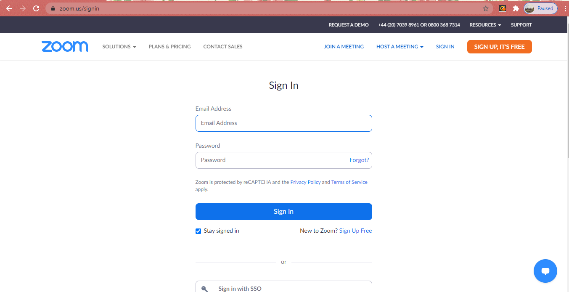
- Go to https://zoom.us/signin and sign into your Zoom account. If you don’t have a Zoom account yet, then select sign up and register for one.
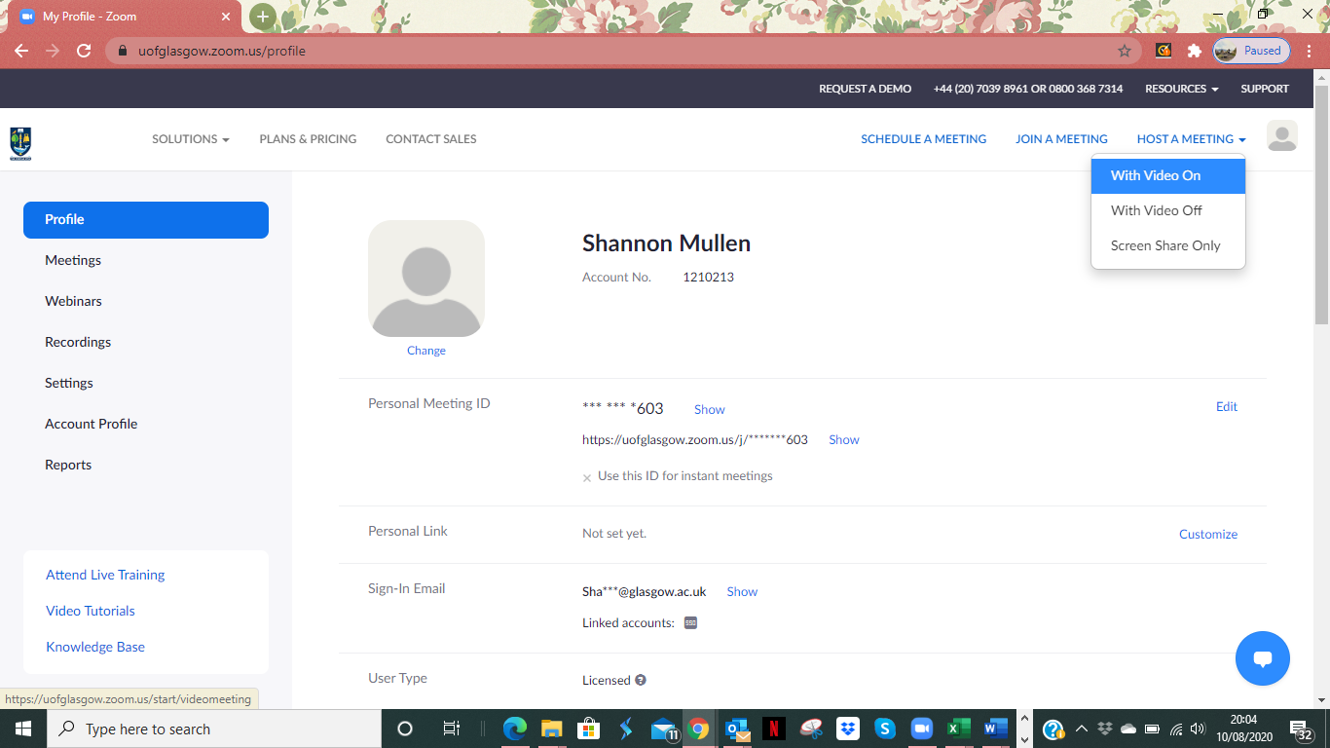
- Once you have signed in you will see your profile page. Select host a meeting in the top right-hand corner and then select ‘with video on’ (or off depending on preference):

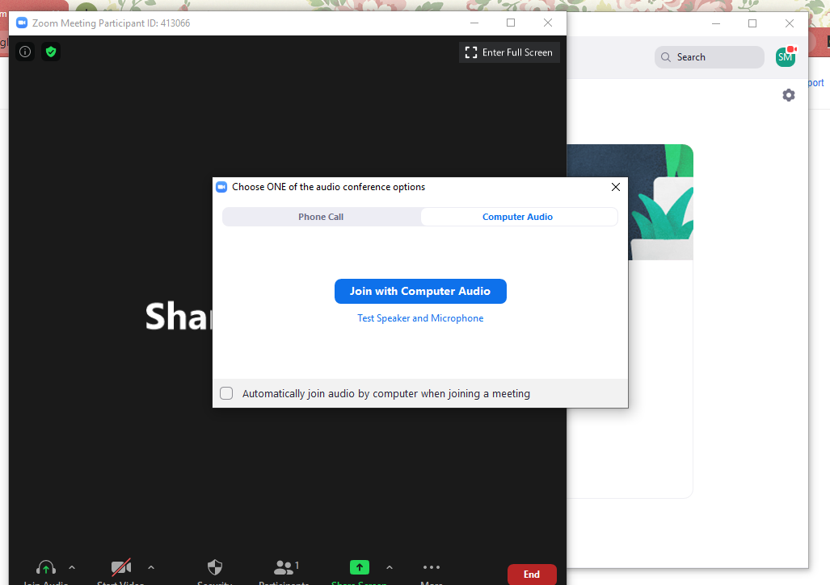
- This will then open up a zoom meeting, select ‘join with computer audio’.
- Select the green ‘share screen’ button on the bottom row. Then select your presentation or the screen you want to share and click the blue ‘share’ button.
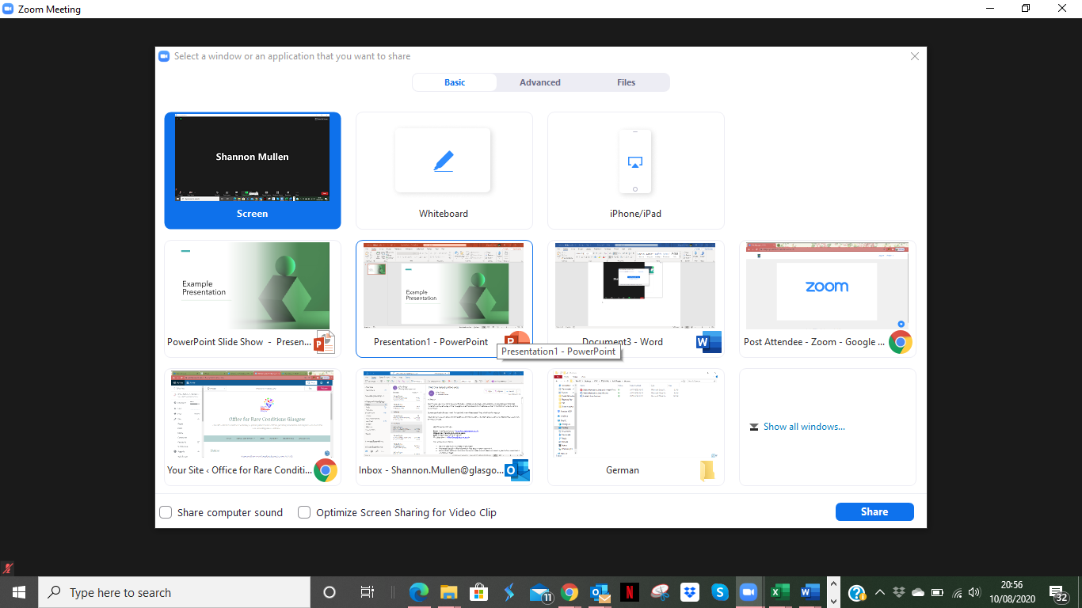

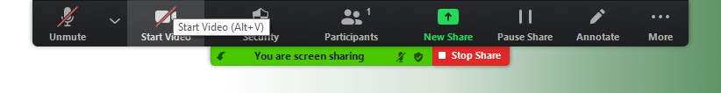
- You are now sharing your screen. The menu bar is now at the top of the page. To unmute yourself and turn on your video select the buttons below from the top bar:
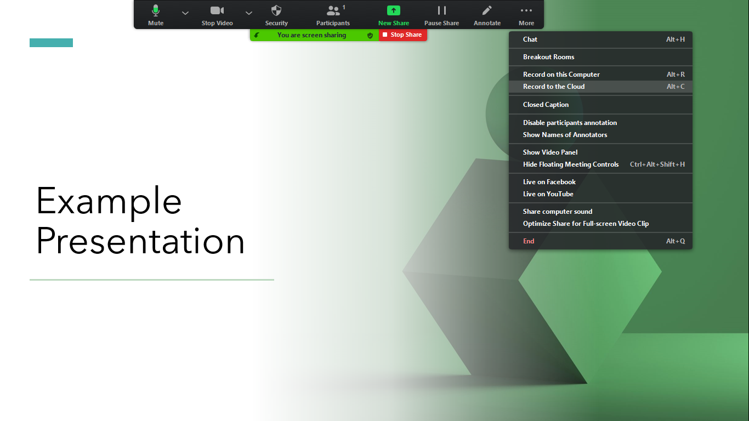
- To start recording your presentation select ‘More’ and then ‘record to the cloud’.
- Your presentation is now recording so you can begin your talk.
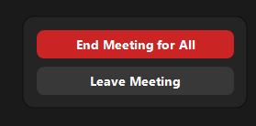
- To end your presentation, select ‘More’ again and click ‘End’ and then ‘End meeting for all’
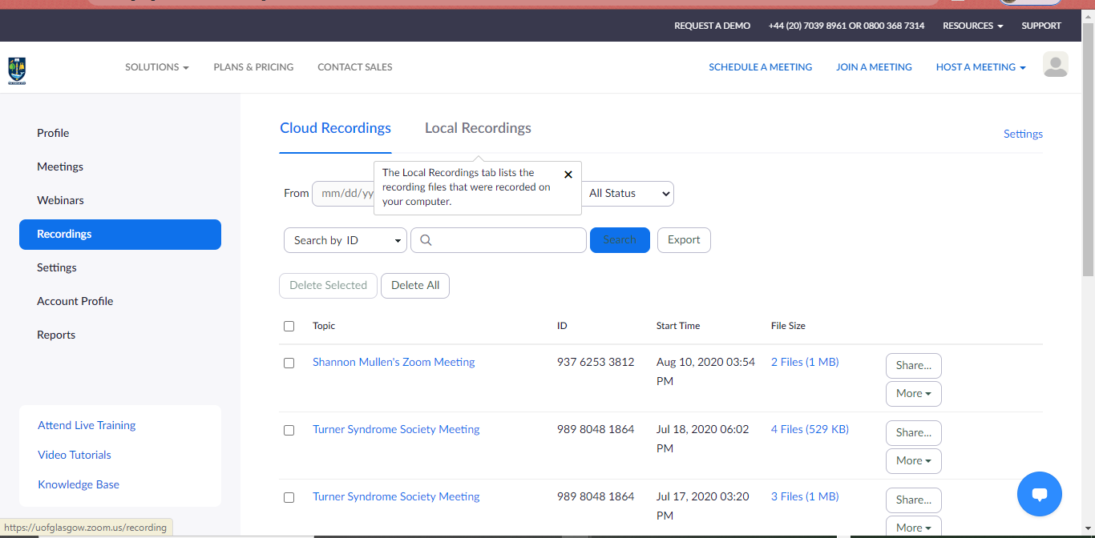
- Your recording will then automatically record and be stored in your zoom account online. Go back to your zoom profile and click the ‘recordings’ option on the left-hand side. All your recordings should be there.

- Select your recording (it should be the top one).
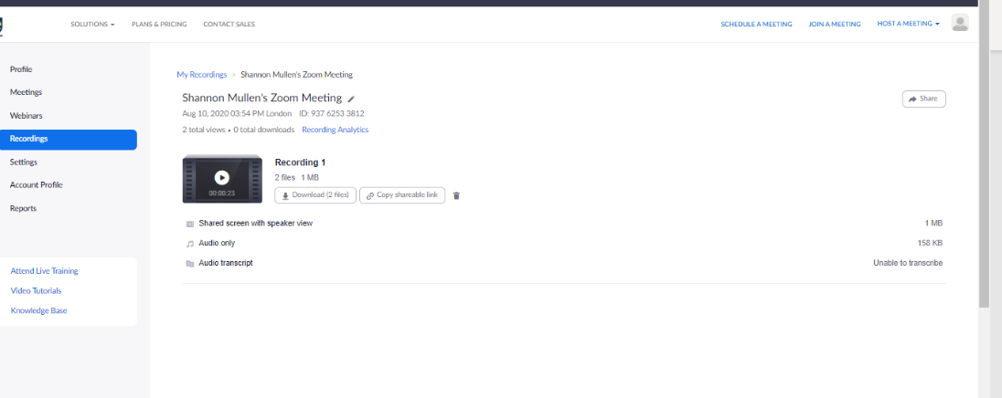
- Now select the ‘share’ button on the right-hand side.
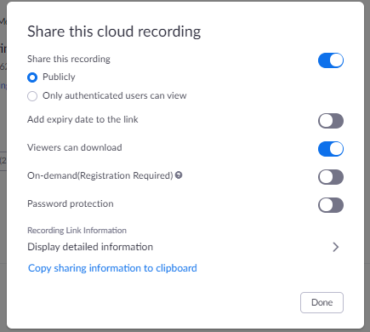
- The following window will appear. To make it easier to share turn off the password protection on the recording. Then select ‘Copy sharing information to clipboard’.
- You can now paste the information and link into an email and share.

