Supporting document for Alex’s interview
These are some terms we discussed in Alex’s interview. They came up on the screen. We don’t explain what they mean so this document has some definitions to help!

Central nervous system (CNS)
This is made up of the brain and the spinal cord. It controls the regulation of the body.
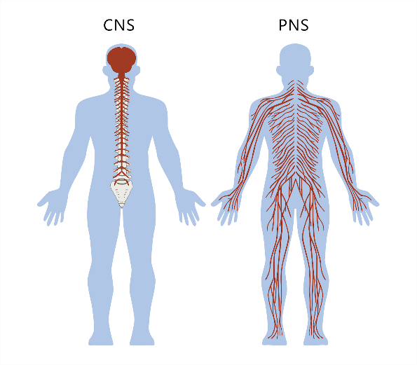
The rest of the nervous system is known as the peripheral nervous system (PNS). This sends and receives messages from the body to the spinal cord/ brain.

(Source: The Partnership In Education)

Blood brain barrier
Click on the link to watch this short youtube video about the blood brain barrier!
https://www.youtube.com/watch?v=sKG81gJuTLM&ab_channel=STAT

Intrathecal therapy (/ lumbar puncture/ spinal tap)
We saw this in the first section about the impact of research. It was introduced as a less harmful alterative to radiotherapy in the brain and is now used practically every month throughout a patient’s treatment!
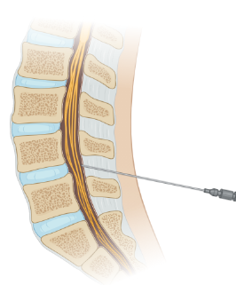

(Created in Biorender.com)

Biomarkers
These are a measurable indicator of a persons disease/ condition. So, in cancer, a biomarker could be a molecule being produced by a tumour, or a molecule being produced by the body in response to a tumour! Alex is using biomarkers to see how much leukaemia there is in the brain, rather than using a microscope as they do now. This is because some leukaemia cells will stick to the walls of the brain and so not be seen under the microscope.

Cell free DNA (cfDNA)
These are broken down bits of DNA released into the blood plasma. It circulates round the body. High levels are seen in cancer so it is also used to look for breast and prostate cancer.
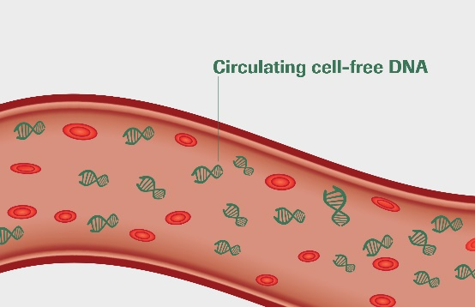
(Source: Roche Sequencing)

Proteins
Everything is formed of proteins! If someone has cancer, different proteins will be formed therefore these can be used to see if/ how much cancer there is.
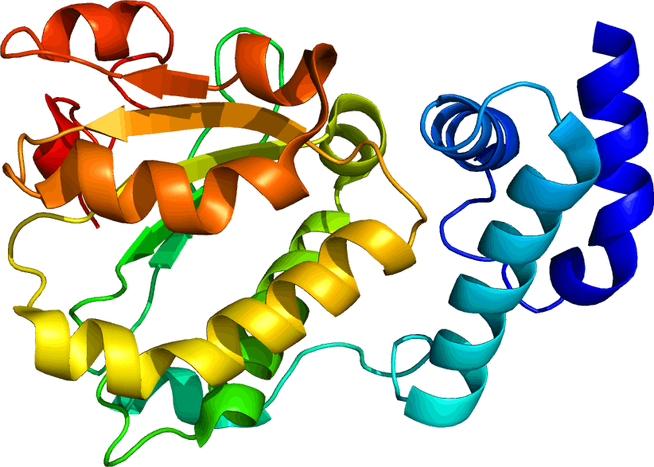
(Source: Wikipedia)

Metabolites
A metabolite is a small molecule which has been made in/ broken down in a metabolic process. A metabolic process is any chemical process in your body which you get energy from eg respiration, breaking down food etc. Metabolism divides into catabolism (breaking things down) and anabolism (building things up).

Cerebral Spinal Fluid (CSF)
This is a clear liquid which surrounds the brain and spinal cord. It provides a barrier for shock and also lubricates the joints.

